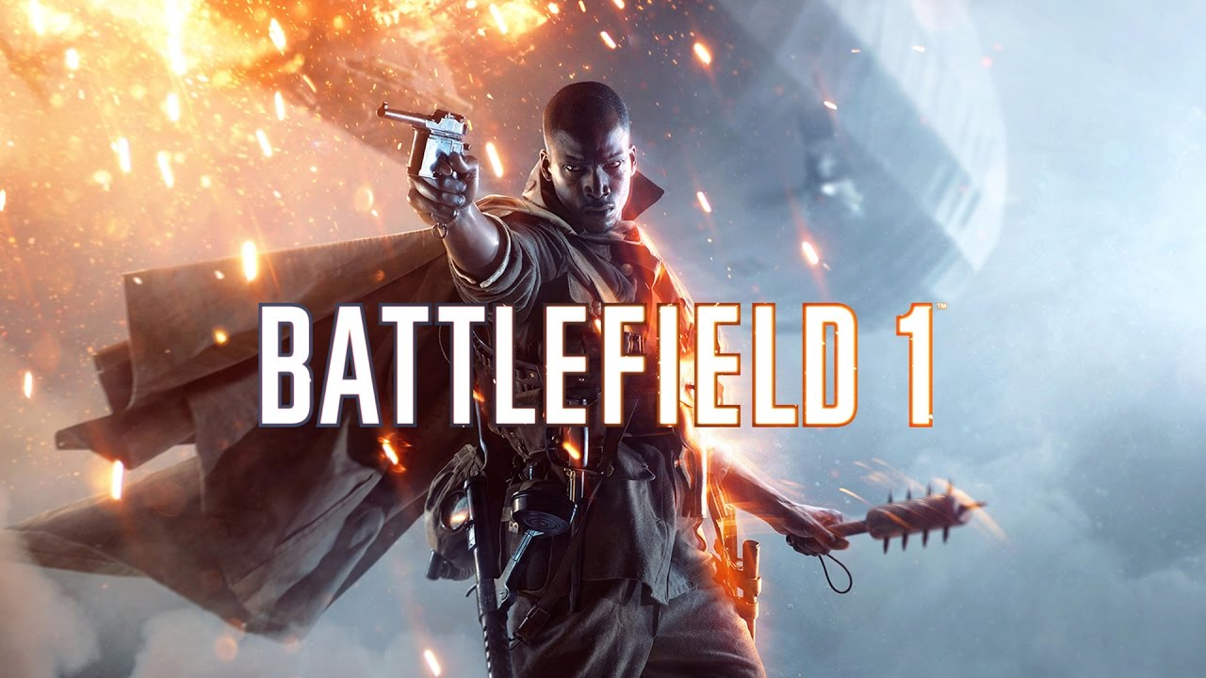

**BATTLEFIELD 1**

**Developed By:**  [DICE](https://www.google.com/search?sa=X&bih=625&biw=1366&hl=en&sxsrf=AOaemvLciOYvvJi9_-jiMXB4q0edeXIo2Q:1640619612162&q=EA+DICE&stick=H4sIAAAAAAAAAOPgE-LVT9c3NEyqrEout6hKUuLUz9U3MEo3LTPSUslOttJPLkvXT87PLSgtSS2KL8tMSc1PT8xNtUpJLUvNyS9ILVrEyu7qqODi6ey6g5URAOa6jE1PAAAA&ved=2ahUKEwilx8apqIT1AhWSLOwKHW4LBW8QmxMoAXoECEIQAw)

**Description:** Battlefield 1 is a first-person shooter video game developed by DICE and published by Electronic Arts. Battlefield 1 is the fifteenth installment in the Battlefield series, and the first main entry in the series since Battlefield 4.

**Platforms:** PlayStation 4, Xbox One, Microsoft Windows

**System Requirement:**

* A minimum computer system that will help you access all function in the game is a Pentium 166 or better.
* 64 Megabytes of RAM or better.

**Published By:**

